**Help Manual Faseegh Abrahams**

Flow of Purchasing a Product on Amazon, Logging in, Checking Order History, and Downloading Invoices:

1. Open a web browser and navigate to the Amazon website ([www.amazon.com](http://www.amazon.com)).

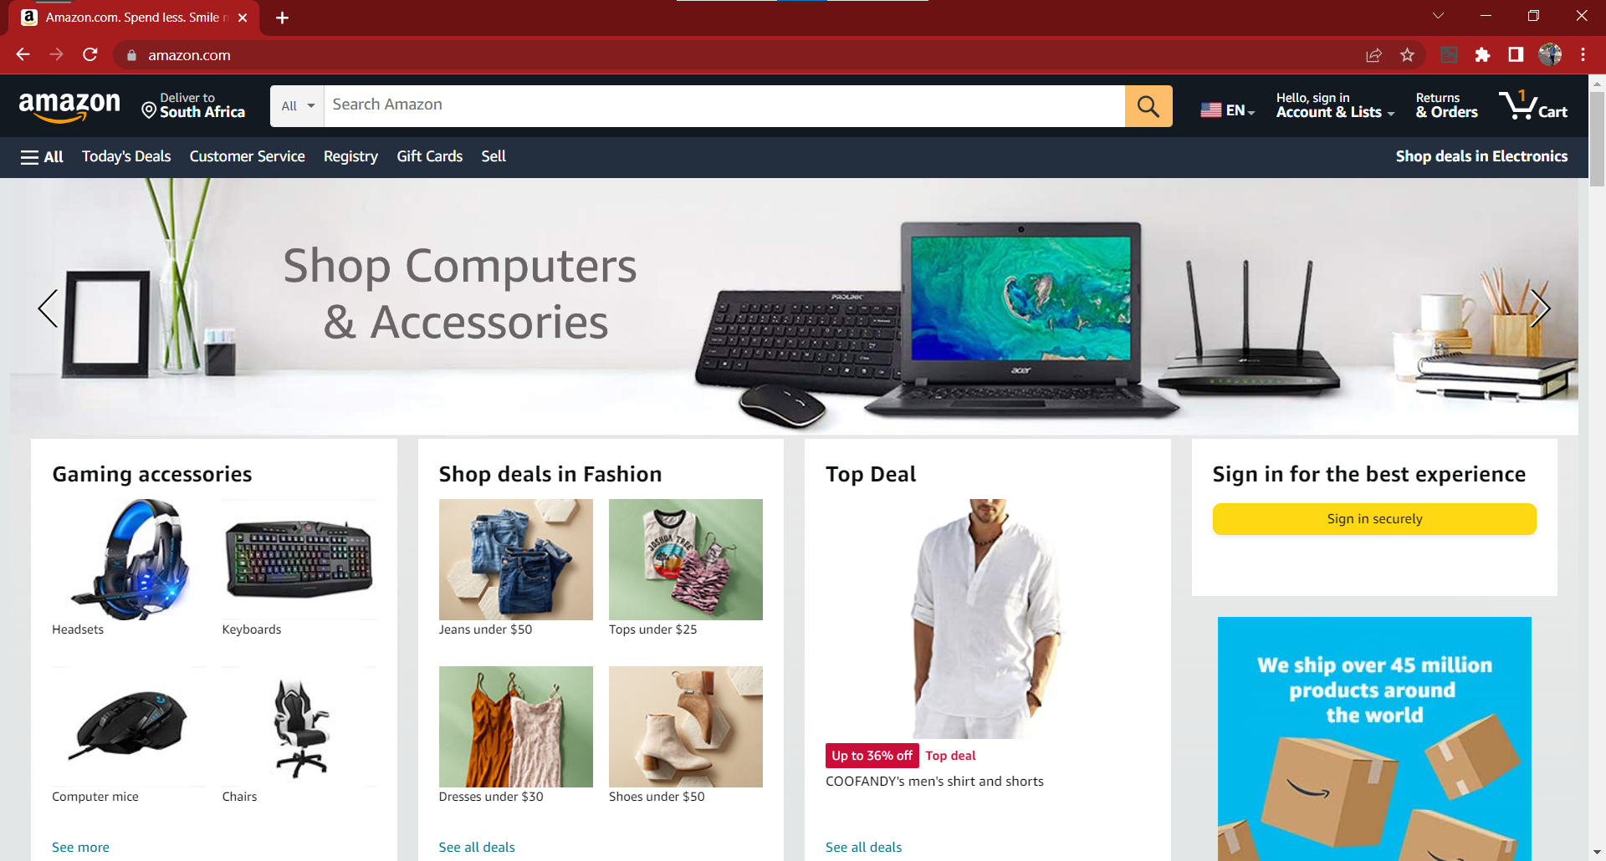

*NB: A New User will be required to create a new account in order to login*

Hover over the “Hello, Sign in” button then click “Start here” button to create a new account.

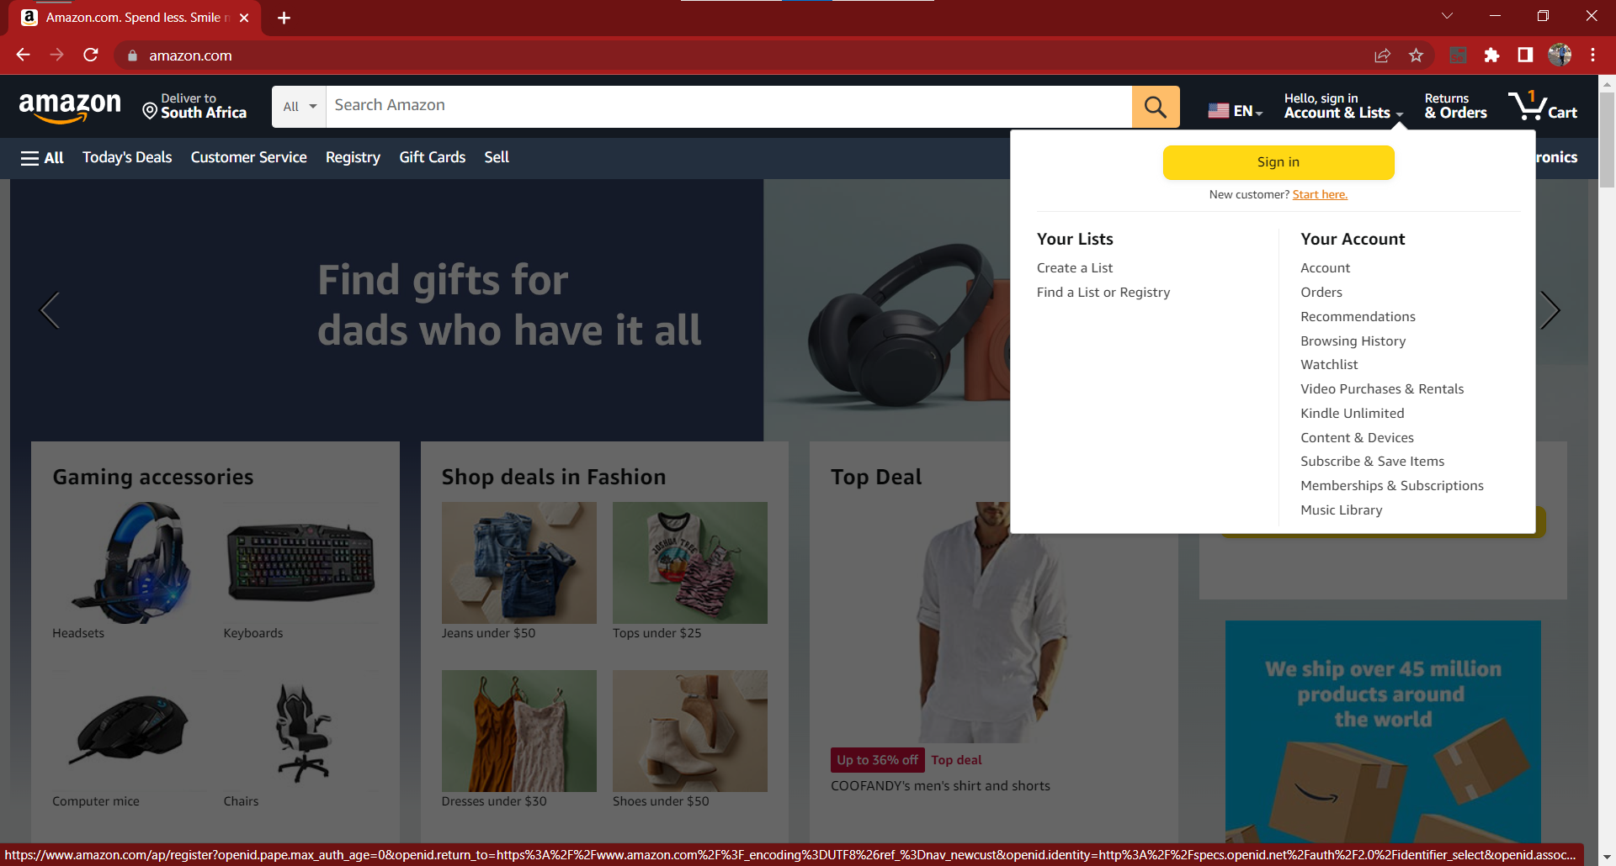

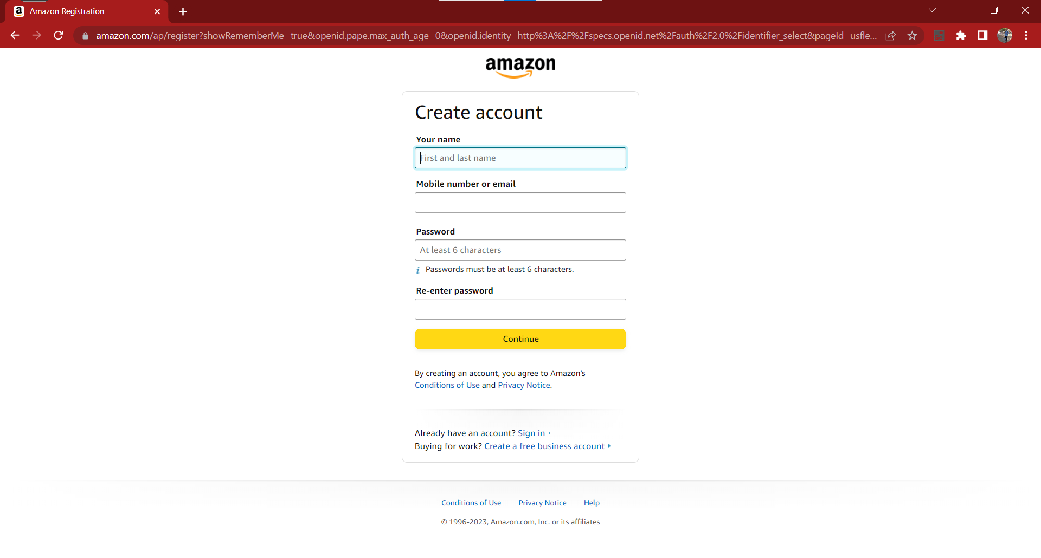

Once the new account creation is completed you’ll be redirected to the home page already signed in

2. **An Existing User** will hover over “Hello,Sign in” and click “Sign In” Button

3. Enter your email address or mobile number and your password, then click on the "Sign In" button.

*Optionally, you may enable the "Keep me signed in" feature to stay logged in.*

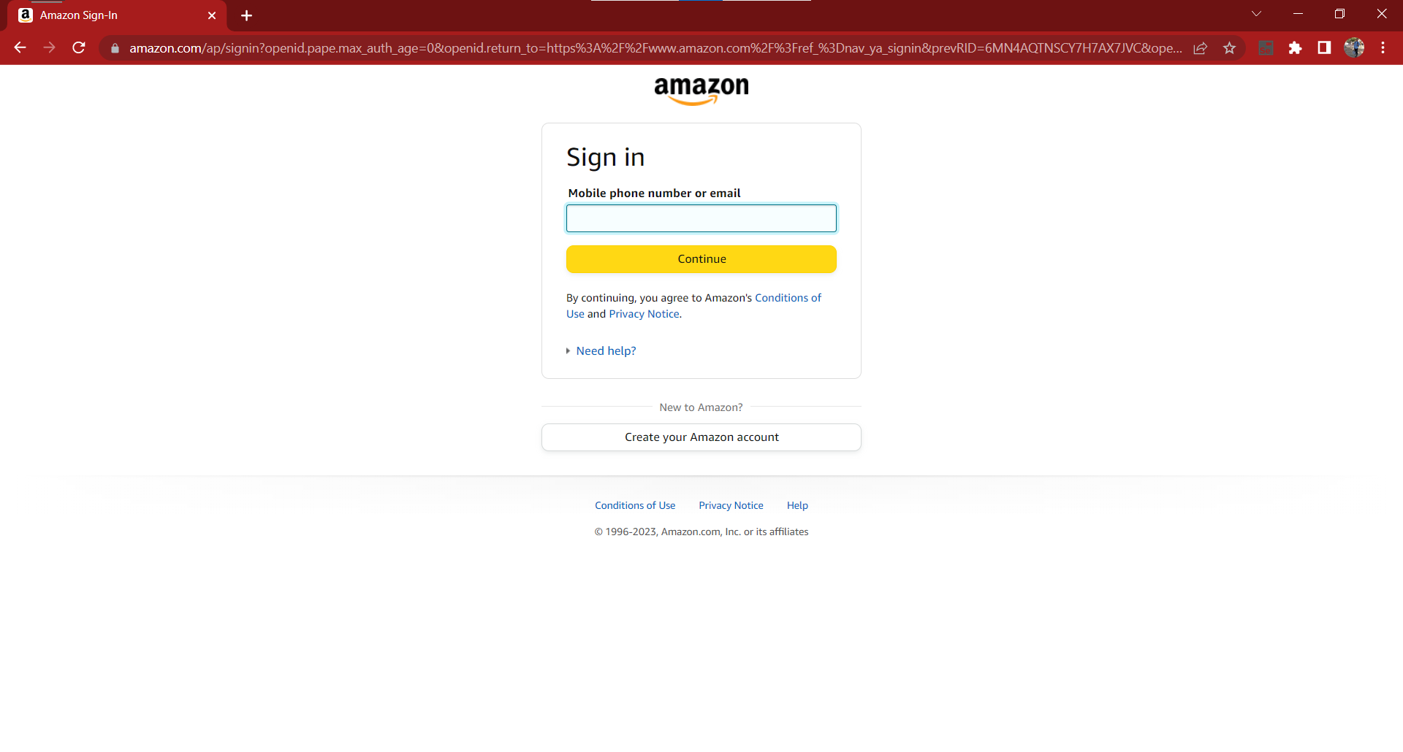

4. You may find a product by:

1. Searching for a specific product by using the search bar

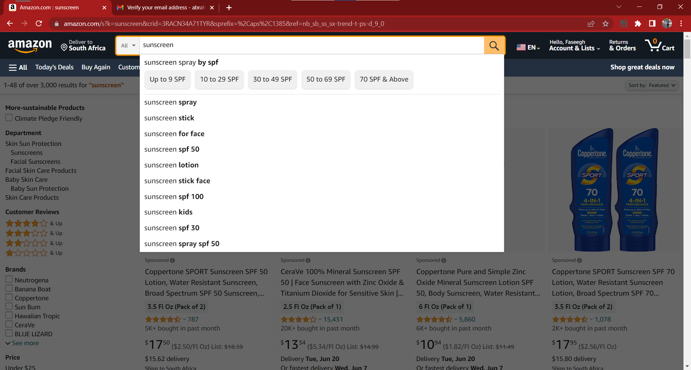

1. Browsing through different categories and departments.

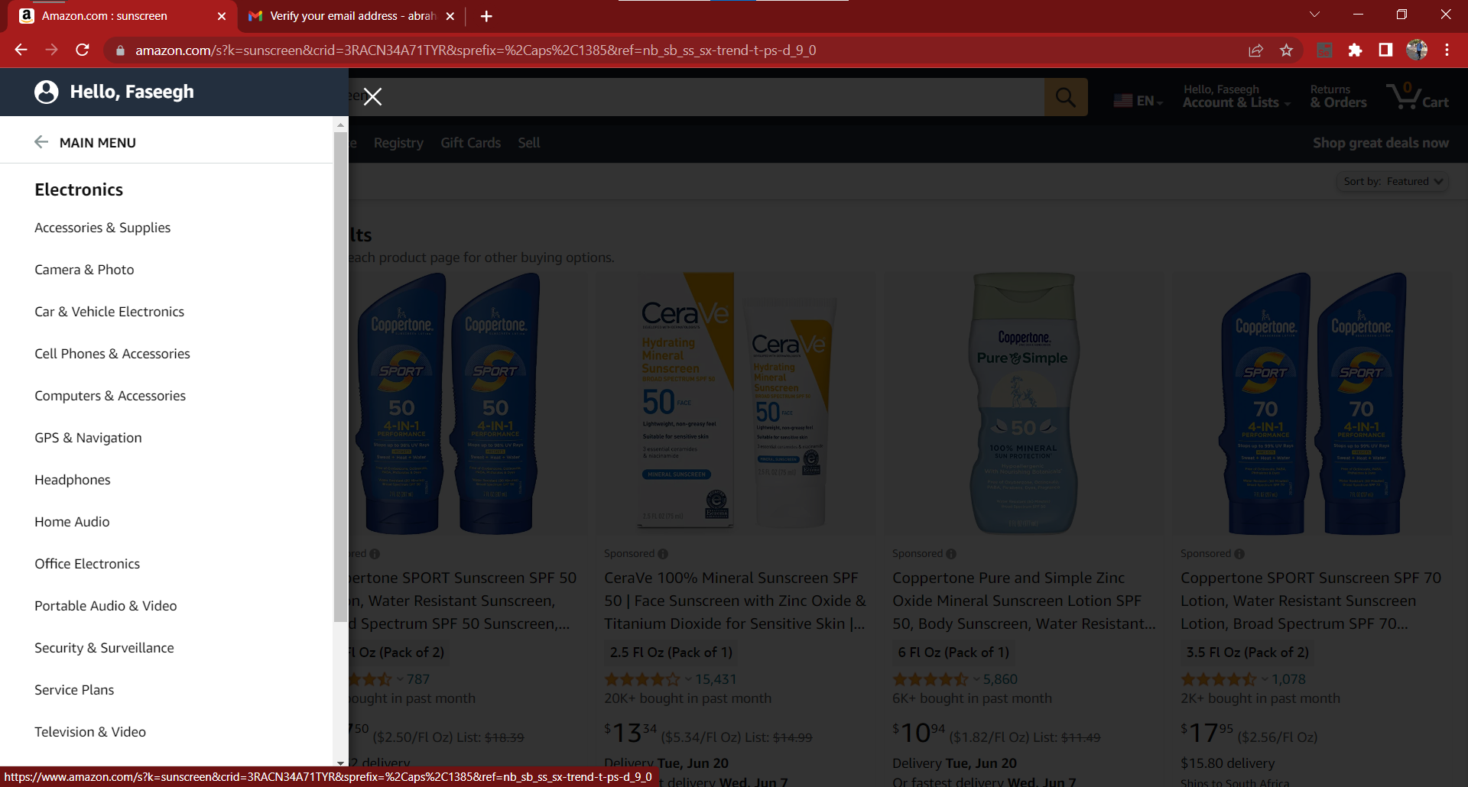

5. When you find the desired product, click on its title or image to view the product details page for more information about the product

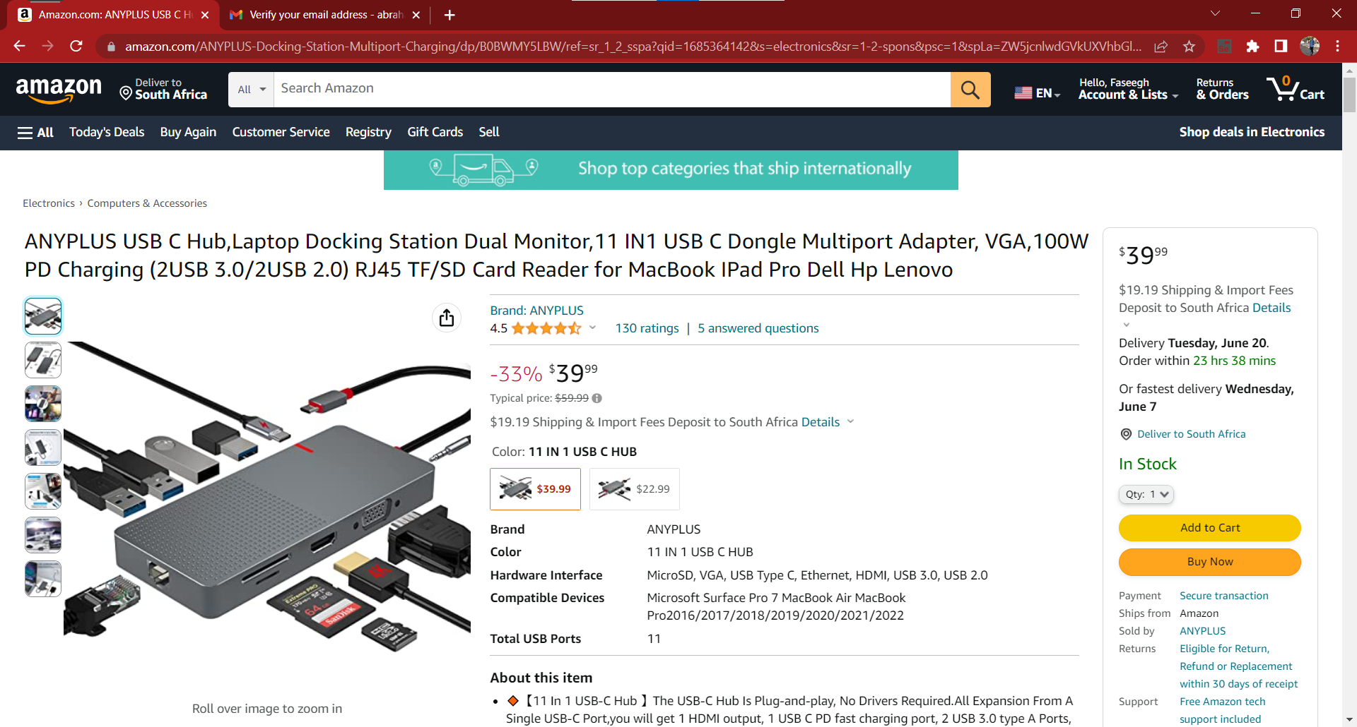

6. To select the item, click on the "Add to Cart" button.

*You can also select different options like color, size, or quantity if applicable.*

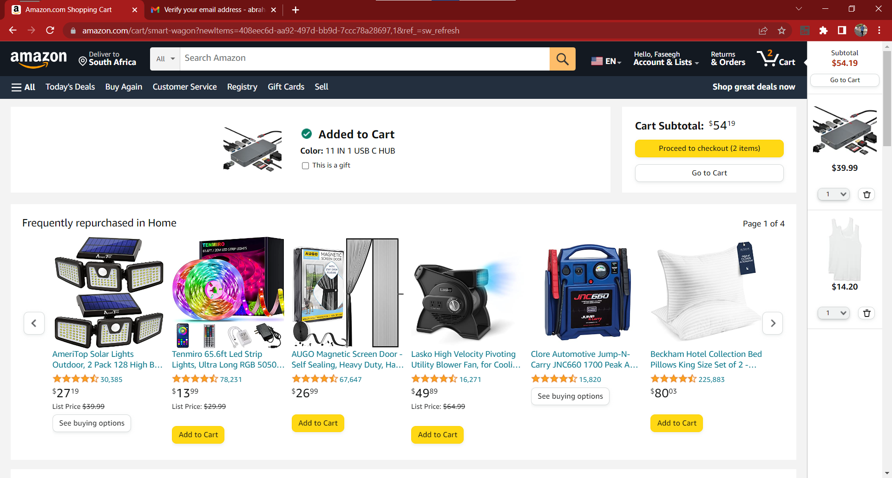

7. Repeat steps 4-6 to add more items to the cart.

8. To proceed to checkout, click on the shopping cart icon located at the top right corner of the page and select the "Proceed to Checkout" button.

9. Fill in shipping information.

*You may also have the option to choose a delivery speed or specify delivery instructions.*

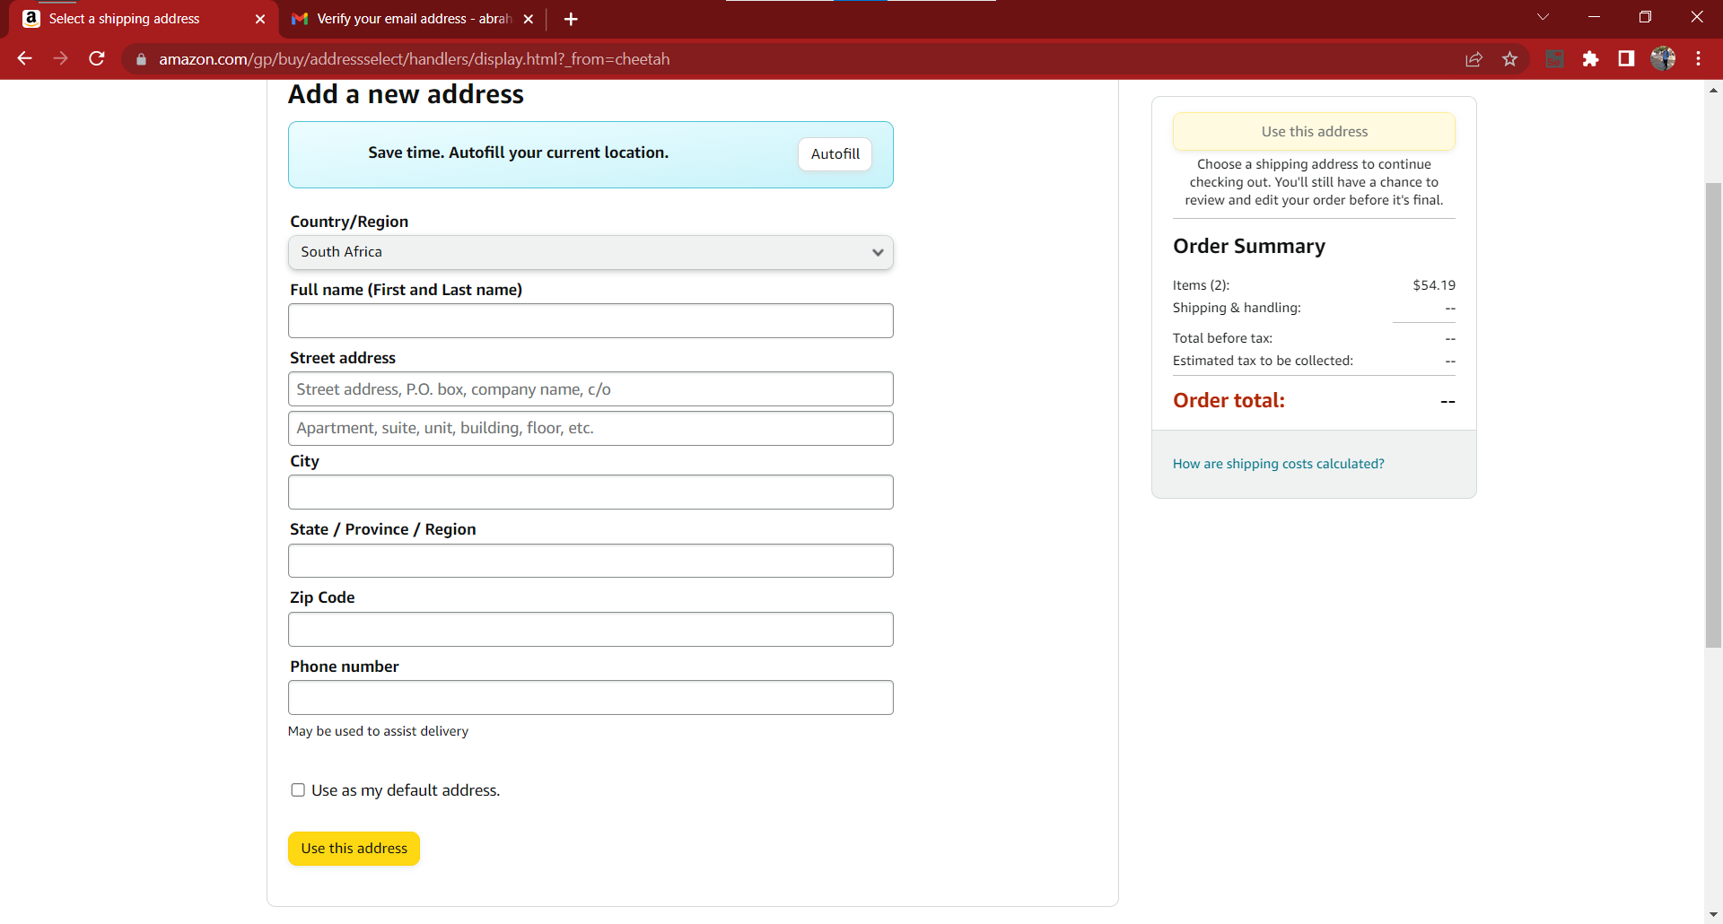

10. Click on the "Continue" button.

*If the product you're purchasing is eligible for Amazon Prime, you may have the option to select free two-day shipping or other Prime benefits.*

11. Select the payment method. Various options are available depending on your region such as credit/debit cards, Amazon gift cards, etc. Follow the instructions to enter your payment details.

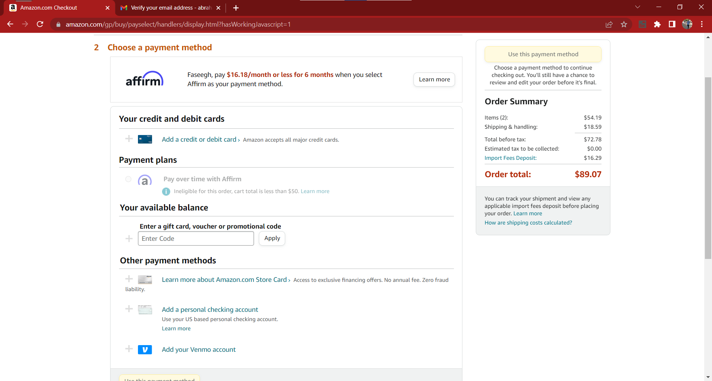

12. Review your order details, including the product, quantity, price, and shipping information. Once verified, click on the "Place your order" button to complete the purchase.

13. An order confirmation page with the details of your purchase will be displayed.

*You will also receive an order confirmation email with the same information.*

To check your order history and download invoices:

1. While logged in to your Amazon account, hover over the "Account & Lists" option located at the top right corner of the page.

2. Click on "Your Orders" in the dropdown menu.

*You will be redirected to the “Your Orders” page.*

3. On the "Your Orders" page, you can view a list of your orders, including the order date, order number, items ordered, and order status.

*You can use the search bar or the filters provided to locate specific orders.*

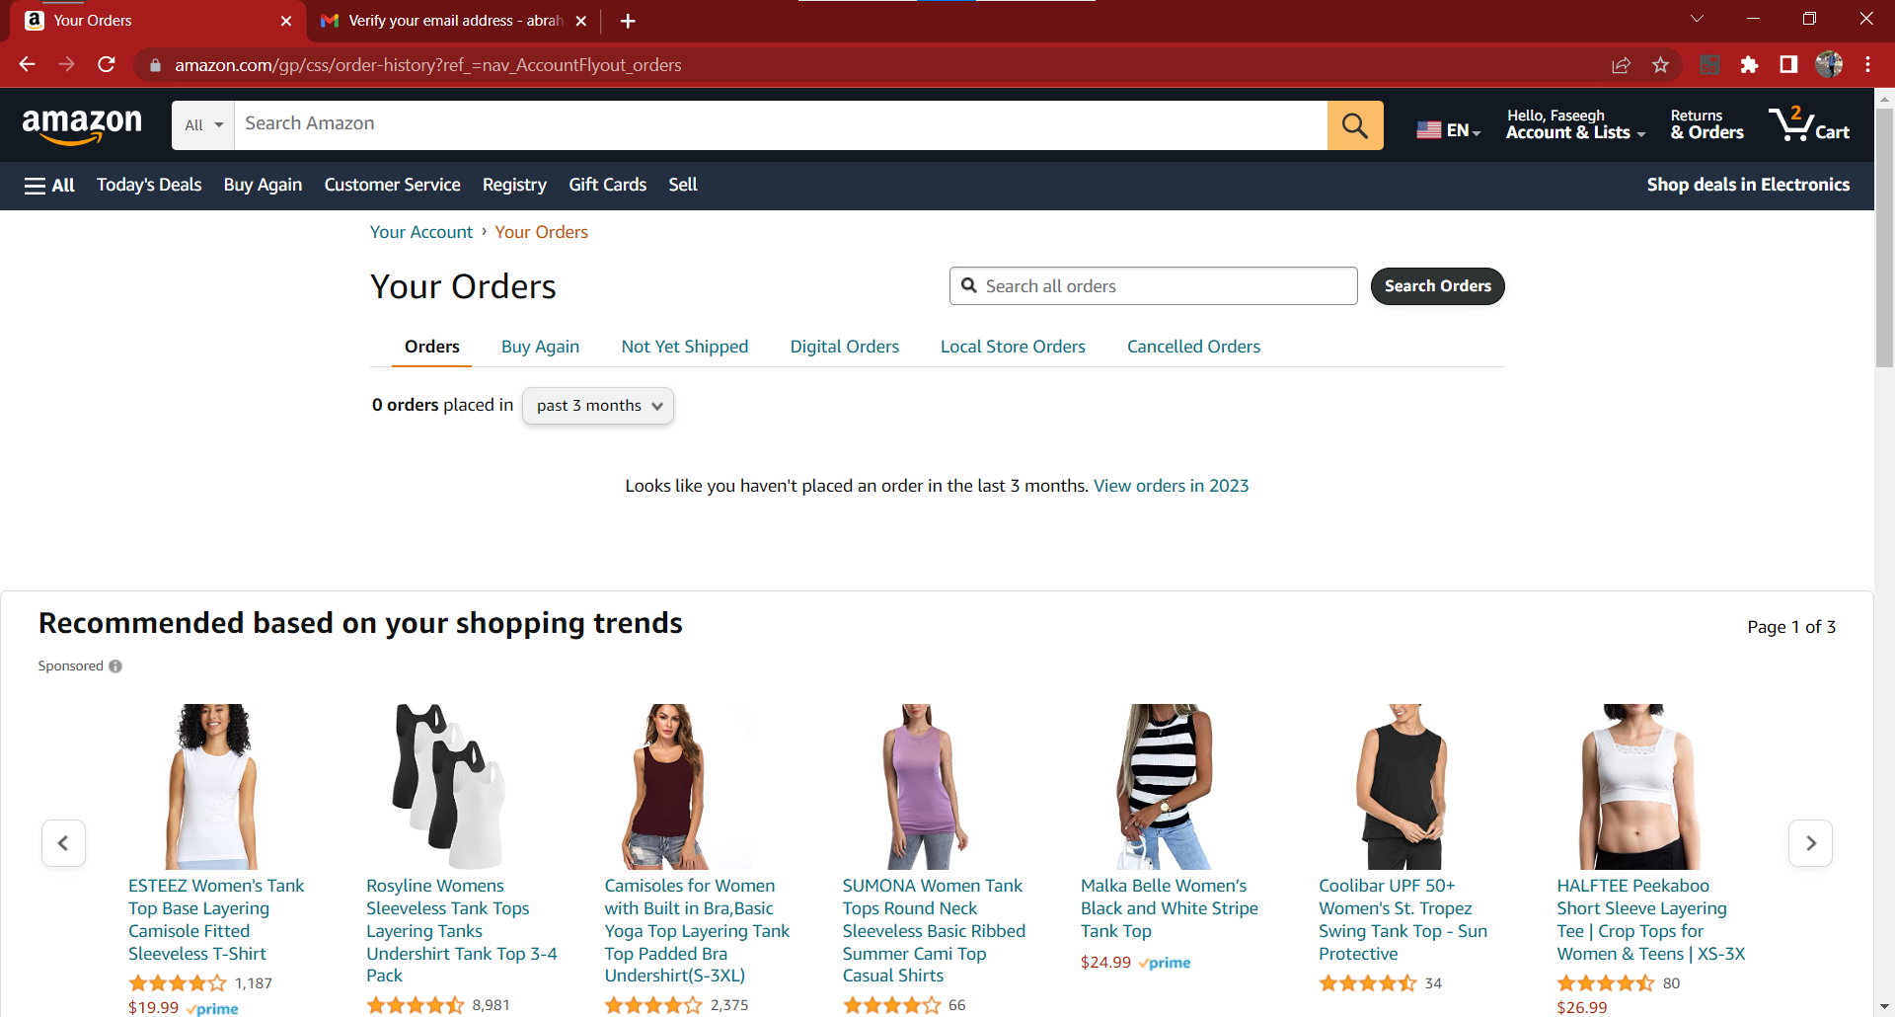

4. To download an invoice for a particular order, find the order you want and click on the "Invoice" button or link associated with it. This will generate a printable or downloadable invoice in PDF format.

5. Once the invoice is displayed or downloaded, you can save it to your device or print the document.